PROJECT PROPOSAL

A Unified Smart Rental, Relocation, and Accommodation Digital Platform

**BY:**  
  
GYASI AMOS KWADWO & ADJEI JOEL  
BSc. INFORMATION TECHNOLOGY  
UNIVERSITY OF GHANA, LEGON

DATE: 31ST AUGUST 2025

**ReloM8**

### PROBLEM STATEMENT

In numerous urban areas in Ghana, including Accra, Kumasi, Tamale, Koforidua, and Takoradi, the issues of relocation and accommodation present substantial challenges. Travelers, students, national service personnel, tourists, and long-term residents frequently encounter difficulties in finding suitable housing, hostels, or hotels transparently and efficiently.

A survey conducted by the Ghana Statistical Service (GSS) in 2021 revealed that over 60% of urban residents reported challenges in securing accommodation due to elevated demand, unregulated rental fees, and the absence of centralized information systems. University students in major cities face even more pronounced difficulties, with the National Union of Ghana Students (NUGS) reporting that over 45% of students experience shortages of hostel accommodation at the beginning of each academic year. Likewise, tourists and business travelers often deal with uncertainties in booking and limited access to verified hotel and guesthouse listings.

On the supply side, landlords, hostel operators, and hotel managers also encounter inefficiencies in connecting with their target clientele. Many depend on informal agents or word-of-mouth advertising, which results in delays, a lack of trust, and lost revenue. Fraudulent activities, such as double-booking and misrepresentation of properties, further undermine confidence in the accommodation and rental market.

The lack of a unified digital platform exacerbates these challenges. While isolated solutions exist for hotels and real estate listings, there is a lack of a comprehensive system that integrates rentals, hostels, hotels, and relocation logistics into a single cohesive platform. This gap leads to significant time wastage, financial risk, and stress for both clients and service providers.

OVERVIEW

**ReloM8 (pronounced: “Relo-Mate”)** is an innovative digital platform aimed at transforming the housing and hospitality experience in Ghana. It serves as a centralized marketplace facilitating direct connections between individuals seeking accommodation, including students, travelers, national service personnel, tourists, and local residents, and providers such as landlords, hostel managers, hotel managers, and logistics companies.

The platform eliminates the need for intermediaries, thereby fostering a transparent, cost-effective, and reliable system for securing accommodations and associated services. ReloM8 enables users to efficiently search and filter available properties, securely book accommodation, conduct digital payments, manage relocation services, and receive real-time updates from providers.

By bridging the gap between clients and service providers, ReloM8 addresses inefficiencies within the housing and hospitality sectors while promoting trust, accountability, and accessibility. Ultimately, the platform significantly contributes to alleviating the challenges associated with urban relocation and accommodation in Ghana's rapidly developing cities.

### SYSTEM VISION

ReloM8 envisions a unified digital ecosystem that transforms how people in Ghana and beyond access and manage accommodation and relocation services. The platform will integrate residential rentals, student hostels, hotels, and relocation logistics into a single, user-friendly web and mobile solution.

At its core, ReloM8 seeks to:

1. Provide tenants, students, travelers, and tourists with a transparent, secure, and convenient platform to search, book, and pay for accommodation.
2. Empower landlords, hostel operators, and hotel managers with digital tools to list, manage, and monitor bookings seamlessly.
3. Connect users with trusted logistics providers to support stress-free relocation and moving services.
4. Ensure secure online transactions through mobile money and integrated payment gateways.
5. Build a trusted marketplace that reduces fraud, eliminates hidden costs, and improves confidence in the accommodation ecosystem.

In the long term, ReloM8 aims to evolve into a national accommodation infrastructure, capable of integrating with government systems for property tax tracking, regulatory compliance, and housing data insights. By merging technology with housing and hospitality needs, ReloM8 seeks to redefine accommodation management in Ghana as a transparent, scalable, and customer-centered experience.

### USER PERSONAS

The personas outlined below represent the primary and secondary stakeholders who will engage with ReloM8. Primary users are the principal beneficiaries of the system and engage with it frequently, while secondary users assume supportive or regulatory roles. By differentiating between these groups, ReloM8 can prioritize features that directly enhance user satisfaction while ensuring compliance and sustainability.

|  |  |  |
| --- | --- | --- |
| USER TYPE | ROLE IN SYSTEM | PRIMARY/SECONDARY |
| Tenant/Traveler | Search, filter, and rent apartments, houses, or short-term stays. | Primary |
| Student | Book campus or off-campus hostels, compare options, and pay online. | Primary |
| Landlord/Property Owner | List properties, manage tenant applications, and approve or decline rentals. | Primary |
| Hotel Manager | List available rooms, manage bookings, and update availability. | Primary |
| Hostel Manger | Manage hostel bed/room allocations, monitor occupancy, and handle payments. | Primary |
| Logistics Provider/ Moving Company | Provide relocation and moving services (transportation, packing). | Secondary |
| Administrator (System Admin) | Oversee system operations, ensure compliance, handle disputes, and fraud reports. | Primary |
| Government / Regulator | Access housing/transaction data for taxation and compliance monitoring. | Secondary |

NB: Unlike the traditional housing sector, where agents act as middlemen, ReloM8 is designed to connect clients directly to providers, reducing costs and increasing transparency.

### REQUIREMENTS AND FUNCTIONALITIES

### FUNCTIONAL REQUIREMENTS

The system shall provide the following key functionalities:

**User Management**

* FR-1: Users shall be able to create accounts and log in securely.
* FR-2: Users shall be able to edit their profiles and manage personal information.
* FR-3: Administrators shall be able to manage user roles and permissions.

**Property / Accommodation Listings**

* FR-4: Landlords, hotel managers, and hostel operators shall be able to create, edit, and delete property listings.
* FR-5: Listings shall include details such as location, price, amenities, pictures, and availability.
* FR-6: Users shall be able to search and filter listings by city, property type, price range, and availability.

**Booking and Rental Management**

* FR-7: Tenants, students, and travelers shall be able to book or rent properties, hostels, and hotel rooms online.
* FR-8: The system shall provide booking confirmations and digital receipts.
* FR-9: Property providers shall be able to accept or decline booking requests.

**Payment Integration**

* FR-10: Users shall be able to make secure payments through Mobile Money, debit/credit cards, and bank transfers.
* FR-11: The system shall generate automated invoices for completed transactions.

**Relocation and Logistics Services**

* FR-12: Users shall be able to request moving/relocation services.
* FR-13: Logistics providers shall be able to accept relocation jobs and update job statuses.
* Notification and Communication
* FR-14: The system shall send automated notifications for booking confirmations, cancellations, and reminders.
* FR-15: Users and providers shall be able to communicate through in-app messaging.

**Administration and Compliance**

* FR-16: The system shall allow administrators to monitor transactions and resolve disputes.
* FR-17: The system shall maintain logs for regulatory reporting and possible government integration.

### NON-FUNCTIONAL REQUIREMENTS

**Performance**

* NFR-1: The system shall handle at least 5,000 concurrent users without performance degradation.
* NFR-2: Pages shall load within 3 seconds under normal conditions.

**Security**

* NFR-3: All sensitive data (passwords, payments) shall be encrypted using industry-standard protocols.
* NFR-4: Users shall authenticate via secure login (with optional two-factor authentication).

**Scalability**

* NFR-5: The system shall be designed to scale horizontally to support future user growth.

**Availability & Reliability**

* NFR-6: The system shall be available 99.5% of the time (excluding planned maintenance).
* NFR-7: Daily backups shall be maintained to prevent data loss.

**Usability**

* NFR-8: The system shall provide a mobile-first responsive interface for accessibility on smartphones.
* NFR-9: The user interface shall be intuitive and require minimal training.

**Maintainability**

* NFR-10: The system shall be modular to support easy maintenance and updates.

**Compliance**

* NFR-11: The system shall comply with Ghana’s Data Protection Act (2012, Act 843).
* NFR-12: The system shall be adaptable to future government property tax integration.

### USE CASES

To ensure that ReloM8 meets the needs of its diverse user groups, use-case modeling is applied. Use cases capture the functional interactions between the system and its actors, offering a clear picture of how users will engage with the platform.

This approach ensures that:

* All stakeholders are considered, from students and travelers to landlords and regulators.
* The system requirements are aligned with real-world user expectations.
* The scope of functionalities remains practical and traceable throughout development.

The following presents the primary use-cases of ReloM8, categorized by actor and their interaction with the system

ACTORS

1. Tenant / Traveler
2. Student
3. Landlord / Property Owner
4. Hotel Manager
5. Hostel Manager
6. Logistics Provider
7. Administrator (System Admin)
8. Government / Regulator (Secondary)

KEY USE CASES

1. Create/manage account
2. Search & filter accommodations
3. Book accommodation (rental, hostel, hotel)
4. Make payments (MoMo, Card, Bank)
5. Manage bookings (approve/decline)
6. List property/accommodation
7. Request relocation service
8. Receive notifications
9. Communicate in-app (chat)
10. Generate reports
11. Resolve disputes
12. Monitor compliance

USE CASE DESCRIPTION TABLE

|  |  |  |
| --- | --- | --- |
| ACTOR | USE CASE | DESCRIPTION |
| Tenant / Traveler | Search & Filter Accommodations | Browse available properties, hostels, and hotels using filters (location, price, amenities). |
| Tenant / Traveler | Book Accommodation | Make reservations for short/long-term stays and receive confirmation. |
| Tenant / Traveler | Make Payments | Pay for bookings securely via Mobile Money, bank transfer, or card. |
| Tenant / Traveler | Request Relocation Service | Request logistics/moving services for relocation. |
| Tenant / Traveler | In-App Communication | Chat with landlords or managers for clarification before booking. |
| Student | Book Hostel Accommodation | Search and book hostel rooms near campus. |
| Student | Make Payments | Pay for hostel booking via integrated payment options. |
| Landlord / Property Owner | List Property / Accommodation | Upload property details, photos, and rental prices to attract tenants. |
| Landlord / Property Owner | Manage Bookings | Approve or decline rental requests, view booking history. |
| Hotel Manager | List Hotel Rooms | Add available hotel rooms and set pricing. |
| Hotel Manager | Manage Bookings | Accept, decline, or update reservations from travelers. |
| Hostel Manager | List Hostel Rooms | Upload hostel details, rooms, and availability. |
| Hostel Manager | Manage Bookings | Accept or decline student bookings. |
| Logistics Provider | Manage Relocation Requests | View, accept, and fulfill relocation service requests. |
| Administrator (System Admin) | Resolve Disputes | Intervene in user-provider conflicts and enforce platform policies. |
| Administrator (System Admin) | Generate Reports | Produce reports on transactions, user activity, and system performance. |
| Government / Regulator | Monitor Compliance | Access compliance data for property taxes, housing regulations, and oversight. |

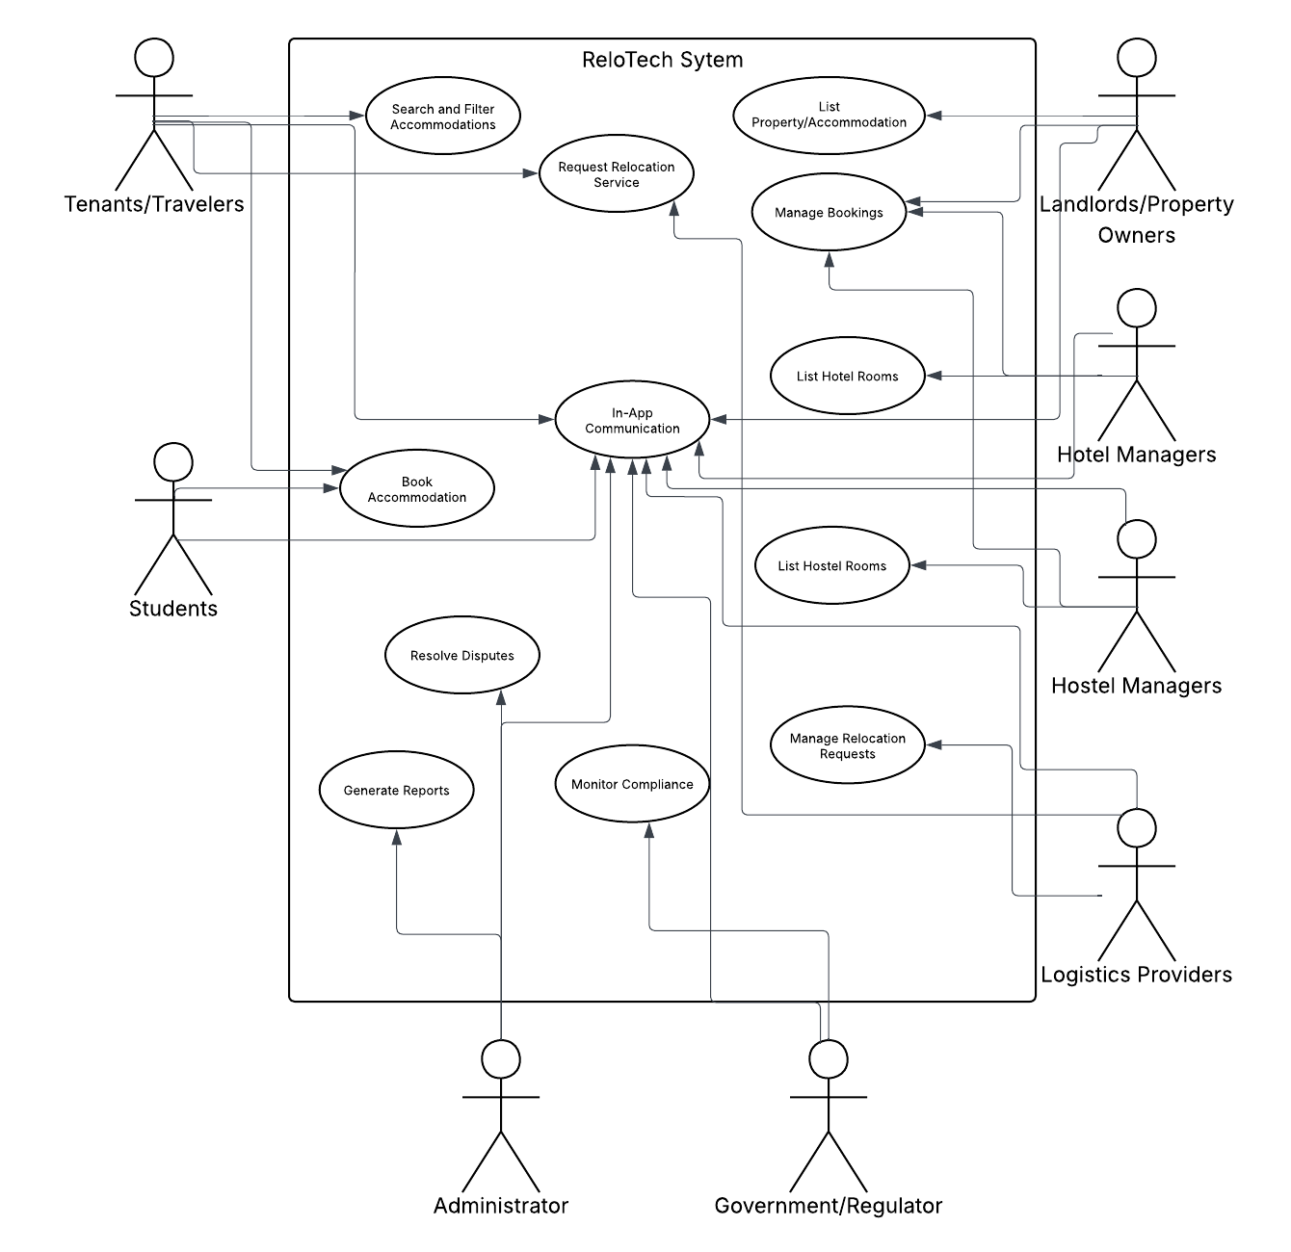USE-CASE DIAGRAM

Figure Use Case Diagram of ReloM8 showcasing the various Actors and their respective Use Cases

### SYSTEM ARCHITECTURE (HIGH LEVEL DESIGN)

ReloM8 is designed as a multi-tier architecture consisting of the frontend (client-facing layer), backend (application logic), database (data management), and external service integrations. This layered design ensures scalability, security, and flexibility for future growth.

FRONTEND (USER INTERFACE LAYER)

* Accessible via **web application** and **mobile application**.
* Provides intuitive dashboards for tenants, students, landlords, hostel managers, hotel managers, logistics providers, and administrators.
* Features include property search and filter, booking interfaces, payment forms, real-time chat, and notifications.

BACKEND (APPLICATION LAYER)

* Powered by a web framework (e.g., Django, Node.js, or similar).
* Handles the business logic, authentication, role-based access control, and communication between users and services.
* Processes booking requests, manages property listings, validates payments, and triggers notifications.

DATABASE (DATA LAYER)

* Centralized relational database (e.g., MySQL/PostgreSQL) to store structured data such as user accounts, property listings, bookings, payments, and relocation requests.
* Ensures data integrity, consistency, and security.
* Backup and recovery mechanisms will be implemented to avoid data loss.

PAYMENT GATEWAY INTEGRATION

* Integrates Mobile Money (MTN MoMo, Vodafone Cash, AirtelTigo Money) and bank cards.
* Provides secure payment handling with encryption and receipts for every transaction.
* Ensures trust and transparency for both clients and providers.

PLOGISTICS AND RELOCATION SERVICES

* Separate service module that connects tenants with registered logistics providers.
* Handles relocation requests, scheduling, and service tracking.
* Ensures communication between tenant and logistics provider.

NOTIFICATION AND COMMUNICATION SERVICES

* Real-time in-app messaging for tenants, landlords, and managers.
* Email and SMS notifications for booking confirmations, payment updates, and reminders.
* Push notifications for mobile users.

ADMINISTRATION AND REGULATION ACCESS

* Admin panel for dispute resolution, report generation, and user management.
* Restricted access for government/regulators to monitor compliance (e.g., property taxes, legal oversight).

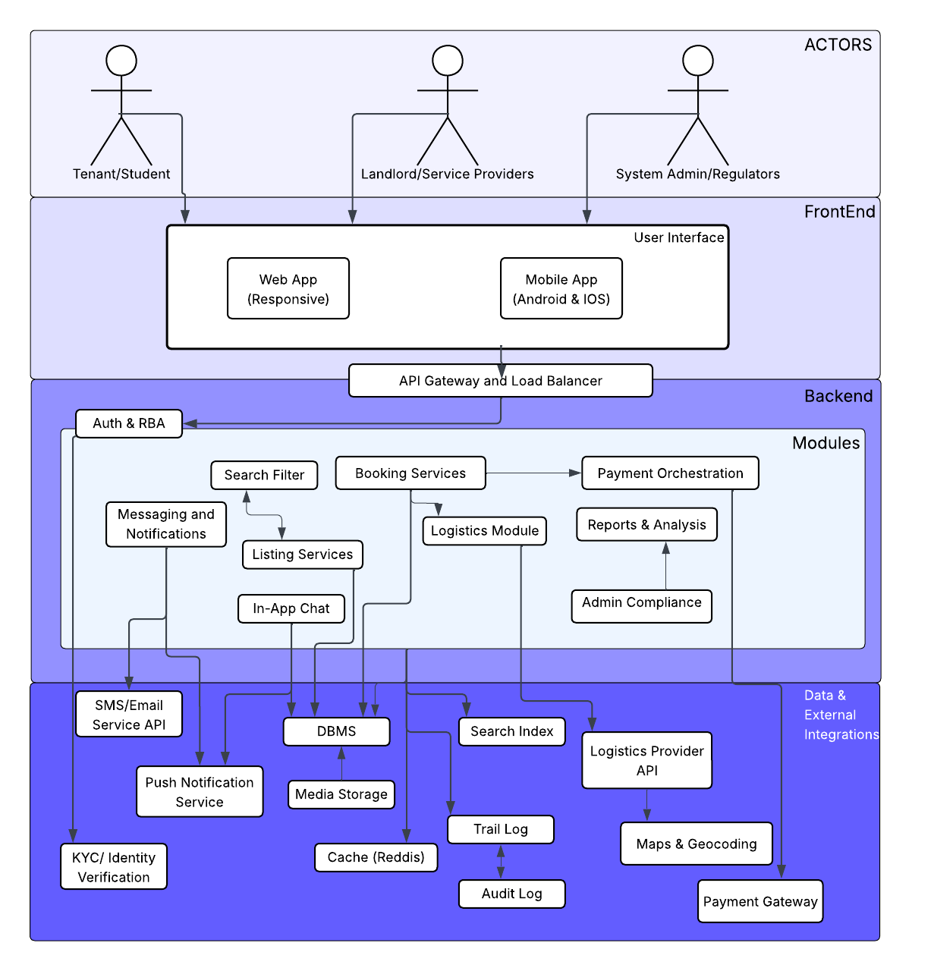SYSTEM ARCHITECTURE DIAGRAM

Figure System Architecture Design

SECURITY CONSIDERATIONS

The success of ReloM8 is significantly contingent upon the level of trust established between users and service providers. In light of the prevalent instances of rental fraud in Ghana, including fraudulent landlords, duplicate listings, and advance payment scams, it is imperative that security is prioritized as a fundamental system requirement rather than an ancillary consideration. Consequently, ReloM8 will implement industry-standard security measures encompassing authentication, data protection, payment systems, and fraud prevention to ensure safe and transparent transactions.

KEY SECURITY MEASURES

1. **User Authentication and Access Control**

* Secure password hashing (bcrypt/Argon2).
* Multi-Factor Authentication (MFA) for property owners and managers.
* Role-based access to restrict actions according to user type (Tenant, Landlord, Manager, Admin).

1. **User Verification (KYC)**

* Mandatory verification for landlords, hostel managers, and hotel operators through national ID (Ghana Card) or business registration.
* Optional verification for tenants to improve trust and accountability.
* Verified badges displayed on listings to distinguish trusted providers.

1. **Data Protection and Privacy**

* End-to-end encryption for sensitive data transmission (HTTPS/TLS).
* Encryption of critical information at rest in the database.
* Compliance with Ghana’s Data Protection Act, 2012 (Act 843) to ensure privacy and lawful handling of user data.

1. **Secure Payments**

* Integration with trusted providers such as MTN Mobile Money, Vodafone Cash, Paystack, and Flutterwave.
* Escrow-style system: funds are held securely until booking confirmation, reducing the risk of advance fraud.
* PCI-DSS compliant payment gateways for card transactions.

1. **Fraud Prevention and Monitoring**

* Reporting and blacklisting system to flag fraudulent landlords, users, or listings.
* Automated fraud detection (monitoring unusual booking patterns or suspicious activities).
* Manual moderation of property listings before they are published.

1. **Audit and Accountability**

* Detailed transaction logs to support dispute resolution.
* Admin dashboard for real-time monitoring of suspicious activity.
* Regular security audits and vulnerability scans.

IMPACT

By embedding these measures, ReloM8 ensures a secure, fraud-resistant ecosystem that protects users, increases trust, and differentiates itself from competitors who rely heavily on agent-driven transactions. Security is not only a technical requirement but also the foundation upon which ReloM8 will build long-term credibility and user adoption.

DATA MODEL

ENTITIES AND THEIR RESPECTIVE PROPERTIES

1. **User**

* UserID (PK)
* FullName
* Email (unique)
* Password (hashed)
* PhoneNumber
* Gender
* UserType (Tenant, Student, Landlord, Logistics, Admin)

1. **Landlord (specialized from User)**

* LandlordID (PK, FK → UserID)
* GhanaCardNumber
* BillingAccount (for payments/receipts)
* BillPaymentReceipt (lightbill, waterbill)

**3. Client (specialized from User)**

* ClientID (PK, FK → UserID)
* ClientType (Student / Tenant / Tourist / NSS, etc.)

**4. LogisticsProvider (specialized from User)**

* LogisticsID (PK, FK → UserID)
* Description (services offered: moving, transport, etc.)

**5. Property**

* PropertyID (PK)
* OwnerID (FK → UserID)
* PropertyType (CommercialRent / Hostel / Hotel)
* Name
* Location
* Description
* Rating
* ApprovalStatus (Pending, Approved, Rejected)
* CreatedBy (FK → UserID)

**6. Room**

* RoomID (PK)
* PropertyID (FK → PropertyID)
* RoomType (Single, Double, Dorm, Suite, etc.)
* Availability (Boolean)
* Price

**7. Booking**

* BookingID (PK)
* ClientID (FK → UserID)
* PropertyID (FK → PropertyID)
* RoomID (FK → RoomID, nullable)
* BookingReference (unique, immutable)
* BookingTime
* StartDate
* EndDate
* Duration (Derived)
* Status (Pending, Confirmed, Cancelled)

**8. Payment**

* PaymentID (PK)
* BookingID (FK → BookingID)
* Method (MoMo, Card, Paystack, etc.)
* Amount
* Date
* Status (Pending, Completed, Failed, Refunded)
* TransactionRef (gateway reference)

**9. Escrow**

* EscrowID (PK)
* PaymentID (FK → PaymentID)
* Status (Held, Released, Refunded)
* ReleaseDate
* HeldBy (System / Admin UserID)

*Purpose: Ensures money is held securely until the booking is fulfilled.*

**10. LogisticsBooking**

* LogBookingID (PK)
* ClientID (FK → UserID)
* LogisticsID (FK → UserID)
* StartingLocation
* EndingLocation
* Distance
* Price
* Status
* Rating

**11. Review (for trust & feedback)**

* ReviewID (PK)
* UserID (FK → UserID)
* PropertyID (FK → PropertyID, nullable)
* LogisticsID (FK → UserID, nullable)
* Rating (1–5)
* Comment
* Date

**12. AuditTrail**

* TrailID (PK)
* Entity (Booking, Property, Payment)
* EntityID (FK → respective table)
* Action (Created, Updated, Cancelled, Approved)
* PerformedBy (FK → UserID)
* Timestamp

*Purpose: Record the timeline of actions for a specific entity (e.g., Booking 123 was created → paid → cancelled).*

**13. AuditLog (System-wide log)**

* LogID (PK)
* UserID (FK → UserID)
* Action (Login, Add Listing, Payment Attempt, etc.)
* Entity (optional: Booking, Property, Payment)
* Timestamp
* IPAddress / Device

*Purpose: Capture all activities across the system for fraud detection & investigations.*

ENTITY RELATIONSHIP DIAGRAM (ER-D)

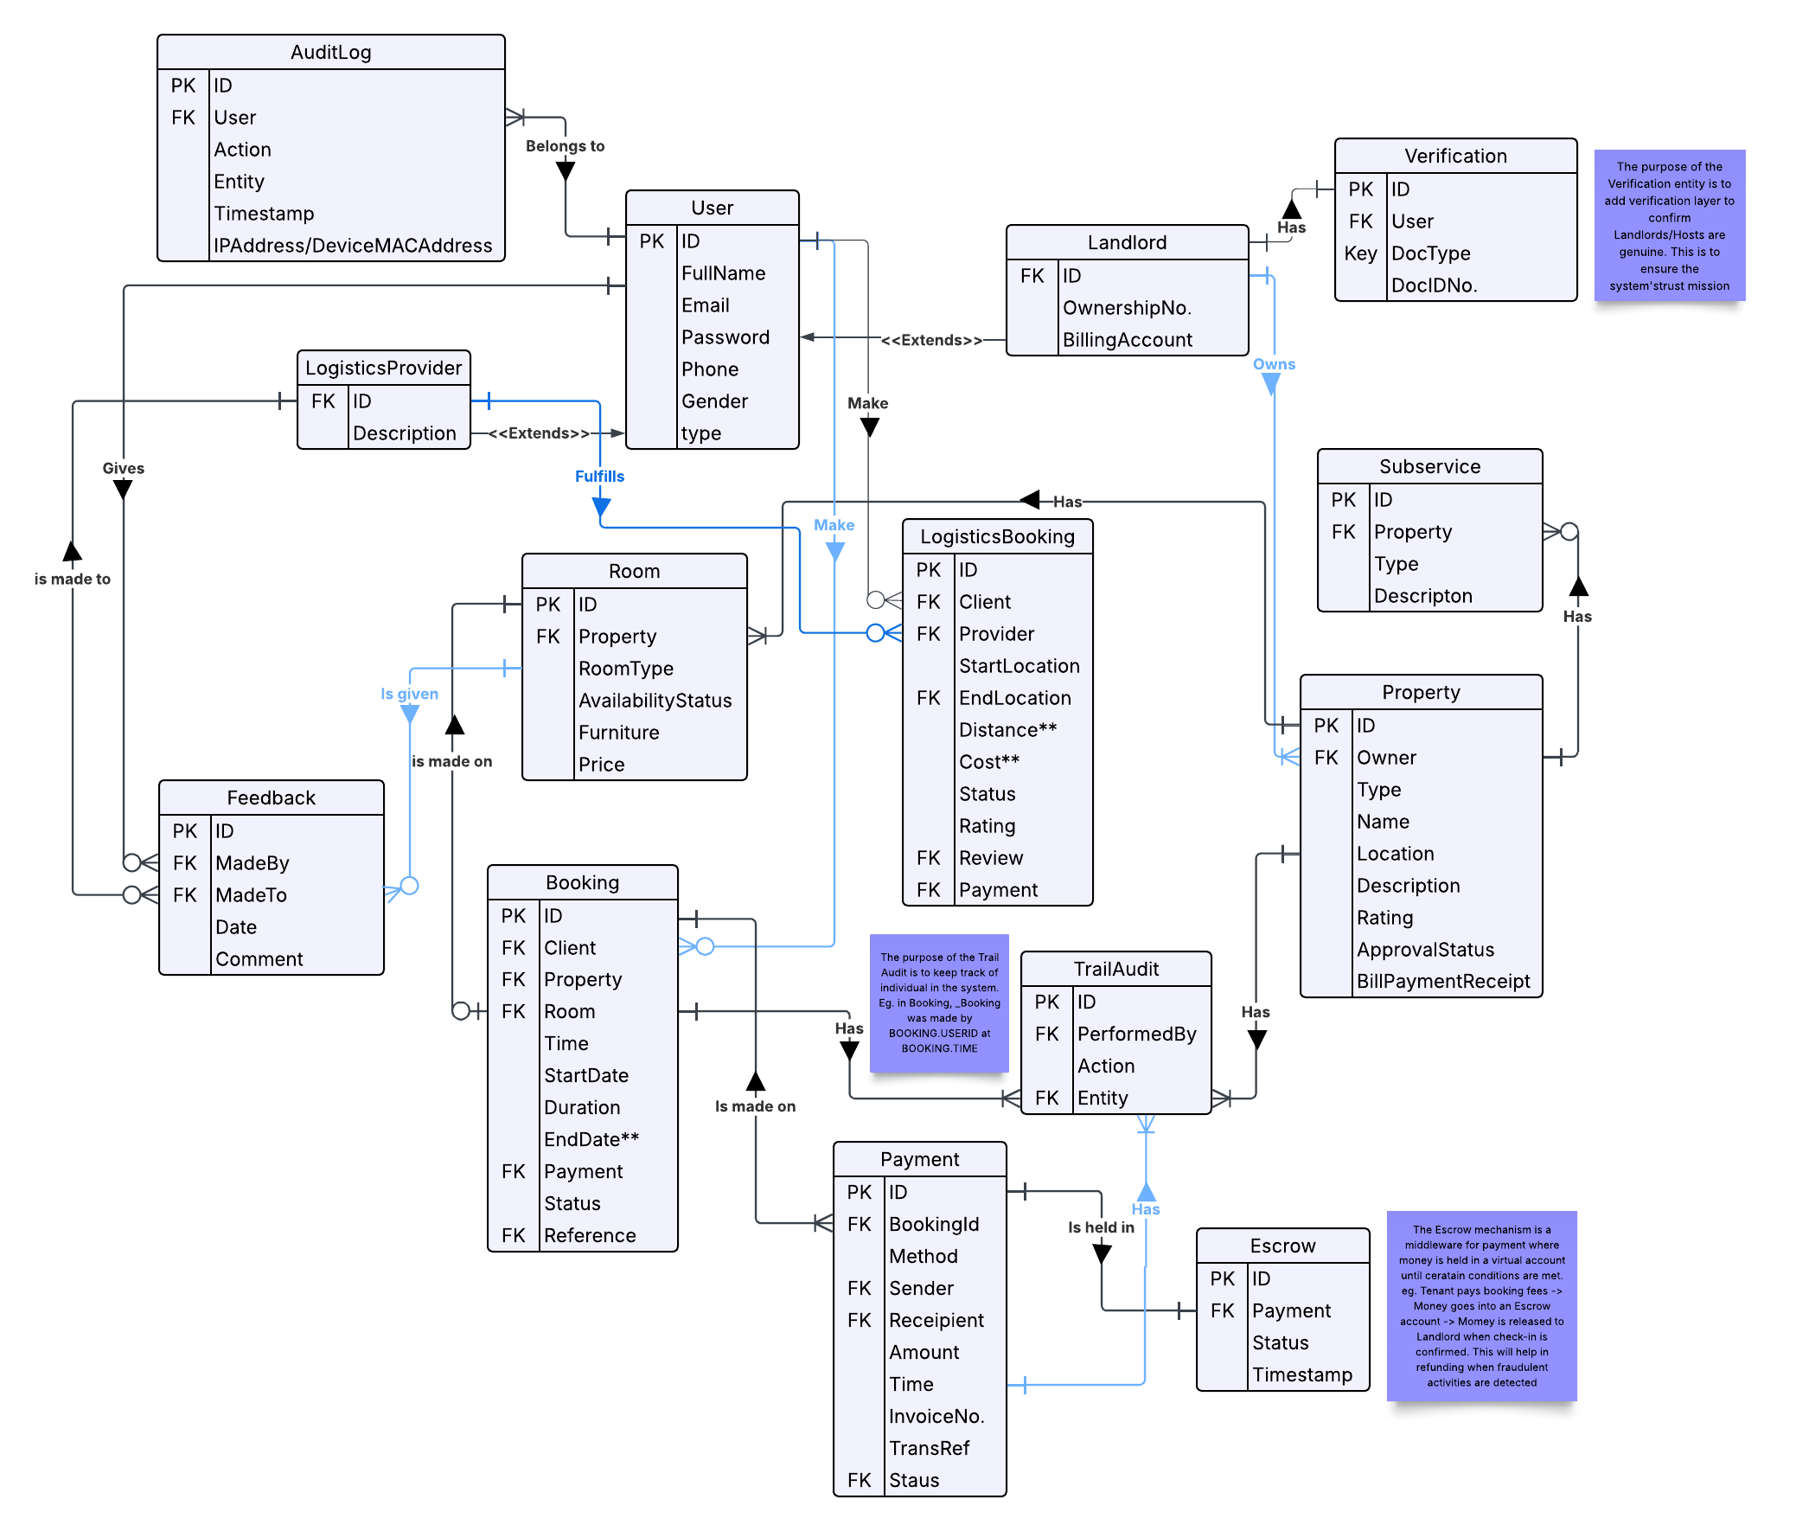

Figure Entity Relationship Diagram showcasing the data model of ReloM8

COMPETITIVE ANALYSIS

The accommodation and relocation landscape in Ghana has witnessed the emergence of numerous platforms designed to facilitate access to housing and hospitality services. Nonetheless, many of these solutions remain fragmented, targeting specific sectors such as student hostels, hotel reservations, or general property rentals, while neglecting critical aspects of integration, logistics, and direct engagement between clients and providers. Examination of the key stakeholders within this sector reveals both the advantages present in the current market and the distinct opportunities that ReloM8 aims to capitalize on.

MARKET CONTEXT

According to the Ghana Housing Profile (2024), more than 60% of urban households reside in rented accommodations, with demand for housing considerably outstripping supply in metropolitan regions such as Accra, Kumasi, and Takoradi. The profile further underscores that a persistent challenge exists regarding student housing deficits in prominent university towns. Concurrently, the hospitality sector, encompassing hotels and guesthouses, has been undergoing expansion to accommodate the growing influx of tourists and domestic travelers. Notwithstanding these developments, the market remains predominantly informal, dependent on agents, and fragmented, leading to inefficiencies for both service providers and consumers.

EXISTING SOLUTIONS AND GAPS

***Hostella***: A digital platform focused exclusively on student hostels, offering online bookings and virtual tours. While innovative, its scope is limited to students, leaving out the wider rental and hotel market.

***GH Accommodation / On Campus Ghana***: Provides listings for student housing across university towns, but lacks relocation services and comprehensive rental or hotel coverage.

***Dwell Ghana***: Offers relocation services tailored mainly to expatriates and executives. However, it functions as a consultancy rather than a scalable digital marketplace, making it inaccessible to the average Ghanaian renter.

***Meqasa, Jiji, and other property apps***: These platforms list rental and real estate opportunities but remain heavily agent-driven, with minimal digital payment or booking integration. This reliance on middlemen often results in high transaction costs and limited transparency.

***Jumia Travel***: Operates in the hotel booking space, focusing solely on hospitality. It does not extend to residential rentals, hostels, or relocation logistics.

ReloM8’s COMPETITIVE ADVANTAGE

ReloM8 is positioned to address these gaps by functioning as an all-in-one digital hub that integrates:

**Residential Rentals**: Verified listings for long-term housing.

**Hostel Accommodation:** Serving students and national service personnel.

**Hotel Reservations:** A hospitality wing for tourists and travelers.

**Relocation Logistics:** Partnered with moving and transport services to support end-to-end relocation.

**Direct Client–Provider Interaction:** Eliminating agent dependency, thereby reducing costs and building trust.

**Seamless Digital Transactions**: Integrated payments, notifications, and booking confirmations.

This unique convergence of services distinguishes ReloM8 from existing competitors, transforming it into a holistic relocation and accommodation ecosystem rather than a single-purpose platform.

SUMMARY COMPARISON

|  |  |  |  |
| --- | --- | --- | --- |
| PLATFORM/SERVICE | FOCUS AREA | LIMITATIONS/GAPS | WHAT ReloM8 ADDS |
| Hostella | Student hostel bookings | Limited to students; no rentals/hotels | Adds rentals, hotels, relocation |
| GH Accommodation | Student housing in university towns | No relocation or hospitality integration | Adds logistics + broader market |
| Dwell Ghana | Executive relocation consultancy | Not scalable; high-end focus only | Affordable, digital, mass-market |
| Meqasa, Jiji | Real estate/rental listings | Agent-driven; lacks direct booking/payment | Direct provider–client model |
| Jumia Travel | Hotel reservations | Hospitality only; no rentals or logistics | Adds rentals, hostels, and relocation |
| ReloM8 | Unified housing + relocation hub | N/A | End-to-end digital ecosystem |

CONCLUSION & WAY FORWARD

ReloM8 aims to address one of the most pressing urban challenges in Ghana: the difficulty of accessing affordable, transparent, and reliable accommodation and relocation services. By integrating residential rentals, student hostels, hotel bookings, and relocation logistics into a unified digital platform, ReloM8 distinguishes itself from existing competitors. It positions itself as a comprehensive ecosystem that caters to the needs of students, travelers, landlords, property managers, and service providers alike.

The competitive analysis, supported by statistics from the Ghana Housing Profile (2024) and the Ghana Tourism Authority, underscores the urgent need for this innovative solution. With over 60% of urban households engaged in renting and a persistent deficit in student housing, the demand for a streamlined service has reached critical levels. Concurrently, the expansion of Ghana’s tourism and hospitality sector further accentuates the market potential for integration with hotels and guesthouses.

The implementation of ReloM8 will encompass several key components:

1. Minimum Viable Product (MVP) Development: Emphasizing verified listings, search functionalities, booking processes, payment systems, and relocation logistics.

2. User Testing and Feedback Mechanisms: Engaging early adopters, including students, national service personnel, and young professionals.

3. Strategic Partnerships: Collaborating with landlords, hostel operators, hotel managers, logistics providers, and payment gateway services.

4. Scalable Expansion: Gradually incorporating advanced features such as Know Your Customer (KYC) verification, modules for government tax compliance, and AI-driven recommendations.

ReloM8 represents not only a technological solution but also a socially impactful innovation that addresses issues of exploitation, enhances the relocation process, and empowers both tenants and property providers through increased transparency and efficiency. By integrating vision, practicality, and scalability, ReloM8 has the potential to establish itself as Ghana’s premier relocation and accommodation platform, serving as a model for digital transformation within Africa’s housing and hospitality sector.

REFERENCES LIST

1. UN-Habitat & Ministry of Works and Housing (2024). *Ghana Housing Profile*. Accra: Government of Ghana.
2. Ghana Tourism Authority (2023). *Annual Report on Hospitality and Tourism and Hospitality Performance.* Accra*:* GTA*.*
3. Hostella. (2024). *Student Accommodation Platform.* Retrieved from <https://www.myhostella.com>
4. Dwell Ghana. (2024). *Relocation Services in Ghana.* Retrieved from <https://www.dwellgh.com>
5. Meqasa. (2024). *Property Rentals and Real Estate Listings.* Retrieved from <https://meqasa.com>
6. Jumia Travel. (2023). *Hotel Booking Platform in Africa.* Retrieved from <https://travel.jumia.com>
7. Jiji Africa. (2023). *Online Marketplace for Real Estate and Rentals*. Retrieved from <https://jiji.com.gh>